WEB DEVELOPMENT
Full name: MAKI PRECIOUS TSOTETSI
Student Number: ST10520801
Lecturer: S MAHUMO
MODULE CODE: WEDE5020
Date: 13 AUGUST 2026

Table of Contents
Introduction 3
Proposal 1: Sizanani Community Care (Non-Profit Organisation) 3
1. Organisation Overview 3
2. Website Goals and Objectives 3
3. Current Website Analysis 4
4. Proposed Website Features and Functionality 4
5. Design and User Experience 5
6. Technical Requirements 5
7. Timeline and Milestones 6
8. Budget 6
9. References 6
Proposal 2: Boutique (Retail Store) 7
1. Organisation Overview 7
2. Website Goals and Objectives 7
3. Current Website Analysis 8
4. Proposed Website Features and Functionality 8
5. Design and User Experience 8
6. Technical Requirements 9
7. Timeline and Milestones 9
8. Budget 9
9. References 10

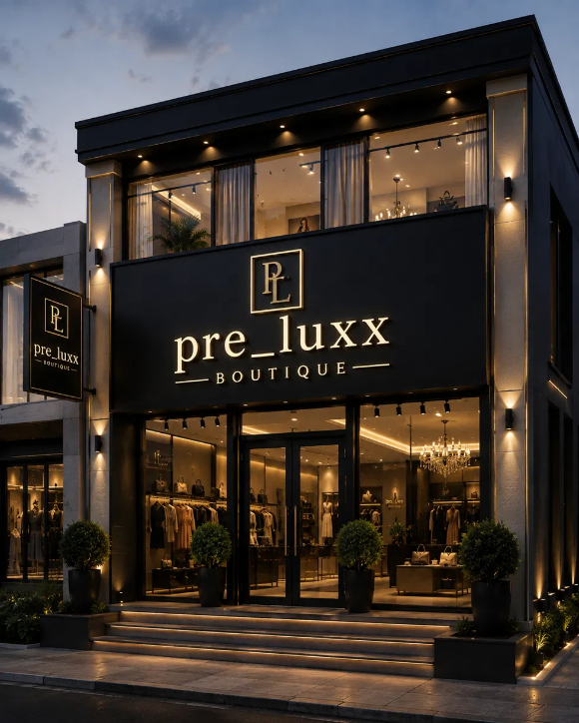
Introduction
This is a WEDE5020 Portfolio of Evidence, Part 1, submission that features two Website Project Proposal options designed based on the brief. There is one each for a Non-Profit Organisation (Sizanani Community Care) and a Retail Store (Aurelle Boutique) which fall under the different categories of organisational types outlined in the brief. Though their content is the author's invention, the organisations themselves are completely made-up and are fictional characters. Yet all details provided are quite accurate and suitable for the respective organisations - goals, budgets, and technology choices.

Proposal 1: Sizanani Community Care (Non-Profit Organisation)

1. Organisation Overview
- Name: Sizanani Community Care
The Sizanani Community Care is a fiction non-profit organisation that was established in 2015 in Mbombela town of Mpumalanga Province by a group of people who were volunteering. These people had their first project of making and providing food to orphans and vulnerable children in the nearby informal settlements as the main thing. In ten-year's time, the organisation has grown to a Non-Profit Company (NPC) and Public Benefit Organization (PBO), registering their status while they continue with their operations through feeding program, after school lessons, and clothes donation to beneficiaries in five surrounding areas.
Mission: The organisation is committed to enhancing the quality, educational, and social development of vulnerable children through food security, learning support, and access to basic requirements.
Vision: The community should be ideal, so each child whether under difficult circumstances or not will be supported to achieve all potentials.
Target audience: Future donors and company sponsors, volunteers interested to donate individual time and energy (parents and guardians). Also the organisation will look for companies interested to join in their activities, parents guardians, local shops, and the entire people of Mbombela town2.

Website Goals and Objectives

The website's primary goal is to establish a credible, easy-to-navigate online presence that increases visibility, builds donor trust, and grows the organisation's volunteer and support base.
- Increase online and once-off donations by providing clear, trustworthy giving information.
- Recruit new volunteers and community partners through a simple enquiry process.
- Communicate the organisation's impact through stories, statistics, and programme updates.
- Serve as a central, professional reference point for corporate sponsors conducting due diligence.

Key Performance Indicators (KPIs)
- Number of volunteer and sponsorship enquiries submitted per month.
- Average monthly website visits and newsletter sign-ups.
- Bounce rate maintained below 50%.
- Growth in repeat visits from returning donors and community members.

3. Current Website Analysis

Sizanani Community Care does not currently operate a website; its only online presence is an intermittently updated Facebook page.

Strengths
- Active, engaged local following on social media.
- Strong existing trust within the communities it serves.

Weaknesses
- No formal, searchable web presence for prospective donors or sponsors.
- No structured way to receive or track volunteer and sponsorship enquiries.
- Inconsistent posting schedule reduces reach and credibility.
- No central place to showcase impact stories or annual outcomes.
A dedicated website would directly address each weakness by formalising communication, enquiries, and impact reporting in one professional space.

4. Proposed Website Features and Functionality
- Homepage (index.html): Hero image of the organisation's work, a concise mission statement, and clear calls to action such as "Donate" and "Become a Volunteer".
- About Us (about.html): Organisational history, mission and vision, and profiles of key staff and volunteers.
- Programmes (services.html): Detailed descriptions of the feeding scheme, tutoring programme, and clothing drives.
- Enquiry (enquiry.html): A form allowing visitors to enquire about volunteering or becoming a sponsor.
- Contact (contact.html): Contact details, an embedded map showing two community centre locations, and a general contact form.
- Supporting elements: newsletter sign-up, social media links, and an image gallery from past outreach events.

5. Design and User Experience
- Colour Scheme: Warm terracotta orange, deep forest green, and sandy beige — evoking community warmth and the Mpumalanga landscape.
- Typography: Open Sans for body text (clear and highly readable) paired with Poppins (bold, rounded) for headings.
- Layout and Design: Clean, mobile-first single-column layout with generous white space and large, accessible call-to-action buttons.
- User experience considerations: Simple, consistent navigation bar across all pages; a persistently visible "Donate" button; descriptive alt text on all images for accessibility.
Low-fidelity wireframes for the homepage and contact page will be developed to visualise layout and information hierarchy before HTML development begins.

6. Technical Requirements
- Hosting: Free static hosting (e.g., GitHub Pages) suitable for the organisation's limited budget, with the option to migrate to shared hosting as it grows.
- Domain name: www.sizananicommunitycare.org.za
- Languages and frameworks: HTML5 and CSS3 for structure and styling, with vanilla JavaScript for basic interactivity (e.g., form validation, navigation menu).
- Assets: Royalty-free and Creative Commons images sourced from platforms such as Unsplash and Pexels, plus Google Fonts for typography.

7. Timeline and Milestones
- Weeks 1–2: Finalise sitemap, wireframes, and gather/organise researched content.
- Weeks 3–4: Build HTML structure and content for all five pages.
- Week 5: Apply CSS styling in line with the design and branding above.
- Week 6: Add JavaScript interactivity and conduct cross-browser testing.
- Week 7: Final review, proofreading, and submission in line with the subject's published deadlines.

8. Budget
- Domain registration: approximately R150–R250 per year.
- Hosting: free (GitHub Pages) initially, or approximately R50–R100 per month if shared hosting is later required.
- Stock imagery and fonts: no cost (Creative Commons / Google Fonts).
- Development: no direct cost, as the site is built as part of a volunteer-driven student project.
Estimated total first-year cost: approximately R600–R1,500, reflecting a realistic, low-budget non-profit context.

9. References
- Nielsen Norman Group (2024) Website usability for nonprofits. Available at: https://www.nngroup.com (Accessed: 9 August 2026).
- World Wide Web Consortium (W3C) (2023) Web Content Accessibility Guidelines (WCAG) 2.1. Available at: https://www.w3.org/WAI/standards-guidelines/wcag/ (Accessed: 9 August 2026).
- Department of Social Development, South Africa (2023) Nonprofit Organisations Act 71 of 1997. Available at: https://www.gov.za (Accessed: 9 August 2026).

Proposal 2: Pre_Luxx Boutique (Retail Store)

1. Organisation Overview
- Name:Pre_Luxx Boutique
Pre_Luxx Boutique is a hypothetical retail store founded in 2016 by Nadia Petersen, a fashion design graduate of the Cape Peninsula University of Technology (CPUT) and former stylist for local South African designers. Located on Minner Street in Pretoria City, Pre_Luxx specialises in elegant, formal occasion wear — evening gowns, tailored suits, bridesmaid dresses, and made-to-measure pieces for weddings, matric dances, and galas.
Mission: To make every client feel elegant and confident for their most memorable occasions, through timeless, beautifully tailored formal wear.
Vision: To become Pretoria’s most trusted destination for elegant occasion wear, blending classic tailoring with modern South African design.
Target audience: Brides and bridal parties, matric dance attendees and their parents, gala and corporate event guests, and professionals seeking formal attire for special occasions.

2. Website Goals and Objectives
The website's primary goal is to let clients browse the collection and book a fitting before visiting in person — essential for a boutique built around personalised, appointment-based service.
- Increase fitting and consultation bookings ahead of key seasons (matric dances, wedding season).
- Showcase the full collection with editorial-quality photography.
- Generate enquiries for made-to-measure and alteration services.

Key Performance Indicators (KPIs)
- Number of fitting/consultation bookings submitted per month.
- Average time spent browsing the collection pages.
- Newsletter sign-ups ahead of matric and wedding season.
- Growth in repeat visits during peak booking periods.

3. Current Website Analysis
Aurelle Boutique does not currently have a website. It relies on a highly active, aesthetically curated Instagram page and word-of-mouth referrals from past clients.

Strengths
- A strong, visually consistent brand presence on Instagram.
- A loyal client base built through personalized in-store service.

Weaknesses
- No way for clients to book a fitting online, so all appointments rely on direct messages or phone calls.
- No structured showcase of the full collection beyond scattered social posts.
- No information available for out-of-town clients planning a visit around a wedding or event.
- No clear channel for made-to-measure or alteration enquiries.

4. Proposed Website Features and Functionality
- Homepage (index.html): A full-bleed editorial hero image, a "Book a fitting" call to action, and a preview of the current collection.
- About Us (about.html): Nadia Petersen's story, the boutique's mission and vision, and an introduction to the atelier team.
- Products (products.html): Categorized collection — evening gowns, tailored suits, bridesmaid and wedding wear, and accessories.
- Enquiry (enquiry.html): A fitting/consultation booking form, with an option to request made-to-measure or alteration services.
- Contact (contact.html): Contact details, an embedded map showing both the Minner Street boutique and the Midrand showroom, and a general contact form.

5. Design and User Experience
- Colour Scheme: Emerald green, champagne gold, and ivory, with charcoal for text — an elegant, editorial palette befitting formal occasion wear.
- Typography: Cormorant Garamond for headings (a refined, high-fashion serif) paired with Jost for body text (clean and modern).
- Layout and Design: A minimal, magazine-style layout with generous white space and large, full-bleed photography, letting the garments lead.
- User experience considerations: A persistently visible "Book a fitting" call to action, simple collection browsing by category, and a mobile-first layout for clients researching on the go.
Low-fidelity wireframes for the homepage and collection page will be developed to visualize layout and information hierarchy before HTML development begins.

6. Technical Requirements
- Hosting: Affordable local shared hosting (e.g., Afrihost or Domains.co.za), suitable for a small boutique retail business.
- Domain name: www.aurelleboutique.co.za
- Languages and frameworks: HTML5 and CSS3 for structure and styling, with vanilla JavaScript for interactivity such as a collection filter and form validation.
- Assets: Professional editorial photography of the collection, supplemented with royalty-free imagery where needed.

7. Timeline and Milestones
- Weeks 1–2: Finalise sitemap, wireframes, and gather/organise collection content and photography.
- Weeks 3–4: Build HTML structure and content for all five pages.
- Week 5: Apply CSS styling in line with the design and branding above.
- Week 6: Add JavaScript interactivity and conduct cross-browser testing.
- Week 7: Final review, proofreading, and submission in line with the subject's published deadlines.

8. Budget
- Domain registration: approximately R200 per year.
- Hosting: approximately R100–R150 per month with a local shared hosting provider.
- Photography: a once-off professional editorial shoot, approximately R3,000–R5,000, reflecting the importance of high-quality imagery for a fashion boutique.
- Development: no direct cost, as the site is built as part of a student project.
Estimated total first-year cost: approximately R4,200–R6,800, reflecting realistic small-boutique hosting, domain, and photography expenses.

9. References
- Baymard Institute (2024) E-commerce UX best practices for fashion retail. Available at: https://baymard.com (Accessed: 9 August 2026).
- Google (2023) Think with Google: Mobile-first design principles. Available at: https://www.thinkwithgoogle.com (Accessed: 9 August 2026).
- Western Cape Government (2023) Small business support and resources. Available at: https://www.westerncape.gov.za (Accessed: 9 August 2026).

